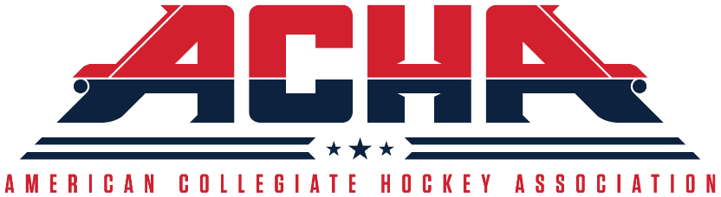
American Collegiate Hockey Association
Standardized Application for Admission
(Rev 03/10/2020)

Looking to join ACHA for the first time?  YES  NO

Already in ACHA and looking to establish new program in another division?  YES  NO

Already in ACHA and looking to move existing program to another division?  YES  NO

Division Requested: Men’s 1 Men’s 2 Men’s 3 Women’s 1 Women’s 2

Institution Name:___________________________________________________________________

Address:__________________________________________________________________________
Street City State ZIP

Phone:____________________Fax:____________________E-mail:__________________________

Name / Title of Individual Completing Application:________________________________________

Address:__________________________________________________________________________
Street City State ZIP

Phone:____________________Fax:____________________E-mail:__________________________

The following questions must be answered in detail on attached pages in typed format and supporting documents must be provided. The ACHA reserves the right to request further information and referral to any and all individuals that may support or confirm the information requested.

- Describe the philosophy of your hockey program and philosophy of the university toward your hockey program? Mission statement must be provided.

- Provide organizational chart. To whom does the hockey coach and/or team administrator report? (athletics, intramurals, student affairs, etc.) Describe the responsibilities of each individual involved in the administration of the program.

- Provide a copy of the hockey program’s charter, by-laws and/or constitution as a student organization with your institution, if applicable.

- Describe the established criteria and selection process of coaches. Are they full-time university/college employees, part time coaches with an appointment in another campus unit, “walk-on” coaches, etc.? Provide job-posting criteria.
- Describe the financial viability of the hockey program. Indicate level (percentage) of funding from each source listed below. Provide answers to this question in the spaces provided.

_____% Funded by university
_____% Funded by corporations/sponsorships
_____% Funded through fund raising
_____% Funded through players dues
_____% Funded through Booster Club
_____% Other (Please List):_____________________________________
Current Budget: $____________
Projected Budget: $____________

- Describe the process to ensure academic integrity of the hockey program and athlete’s progress toward degrees. (academic advising, tutorial sessions, study tables, mid-term progress report forms, etc.)

- Do you have an athlete’s Code of Conduct that is reviewed and signed by each player prior to the beginning of the season? Provide copy.

- Describe the facilities used for practices and games. Are the facilities owned by the institution or rented? How far is the arena(s) from the campus? Seating capacity and rink dimensions of all surfaces used? Do you have your own dedicated locker room? Does each locker room at the arena(s) have showers within the locker room? Average attendance per home game? Ticket prices per game?

- Describe the financial aid given to hockey players. (housing, books, board, tuition discounts, scholarships, federally funded aid etc.) Please provide the following statistics related to financial aid (failure to provide these may delay your application):
a. What percentage of non student-athletes receive the financial aid described in your answer above
b. What percentage of student-athletes receive the financial aid described in your answer above?
c. What percentage of current ice hockey student-athletes receive the financial aid described in your answer above?

- Do you provide a team physician and/or certified athletic trainer for games and practices? Are your players required to carry their own health insurance?

- Provide timetable of a season of competition. For example, team(s) are allowed x amount of games. Season begins on X date and ends on X date.

- Provide timetable of practices. For example, team(s) are allowed x amount of practices. Practice begins on X date and ends on X date.

- Describe any camps that the hockey program operates and their purpose. Give the dates or approximate date(s) when the camp(s) are operated.

- Have you reviewed the ACHA Manual? Do you understand the ACHA’s Operating Policies as well as those policies for the ACHA Division to which you are applying?

- Provide any other pertinent information that should be reviewed by the ACHA that would support your request for membership.

INSTRUCTIONS AND PROCEDURE

- Applications can be downloaded from the ACHA website or requested from the ACHA Director of Hockey Operations.

- Teams may apply only once per season.

- There is a non-refundable $300.00 USD application fee, which must be paid online at the link below:

http://www.shopacha.com/product/M1-Add.html

- The completed Application and proof of application fee payment must be submitted to ACHA Director of Hockey Operations.

- Upon receipt of the application and application fee by the ACHA Director of Hockey Operations, the application will be reviewed by the ACHA Director of Hockey Operations, the respective Division Vice-President and the respective Division Commissioner on behalf of the ACHA (collectively, the “Membership Committee”). The ACHA will seek to render a decision on acceptance or denial of the application within fifteen (15) business days.

- The Membership Committee will decide by vote if a team is admitted to the Division to which they have applied.

- A majority of yes votes returned will grant the applicant admission into the Division requested for the following season.

- If the Membership Committee determines that the applicant would be more suited to another Division, they may, in consultation with the appropriate Division Commissioner, recommend applicant accept membership in another Division.

- If a majority of yes votes is not reached, or if the applicant chooses to not accept admission in another Division than that to which they applied, the application shall be denied.

- Once an applicant has been approved, the Member Program must give their written acceptance within five (5) business days.

- For teams seeking admission to Men’s Division 1 and/or Women’s Division 1, there are application deadlines. No applications will be considered for Men’s Division 1 and/or Women’s Division 1 after the respective deadline has passed for that season, including applications from existing ACHA teams in other divisions.

- Any Member Program that has given their written acceptance but does not play in the upcoming season will not be eligible for the National Tournament during the upcoming season.

