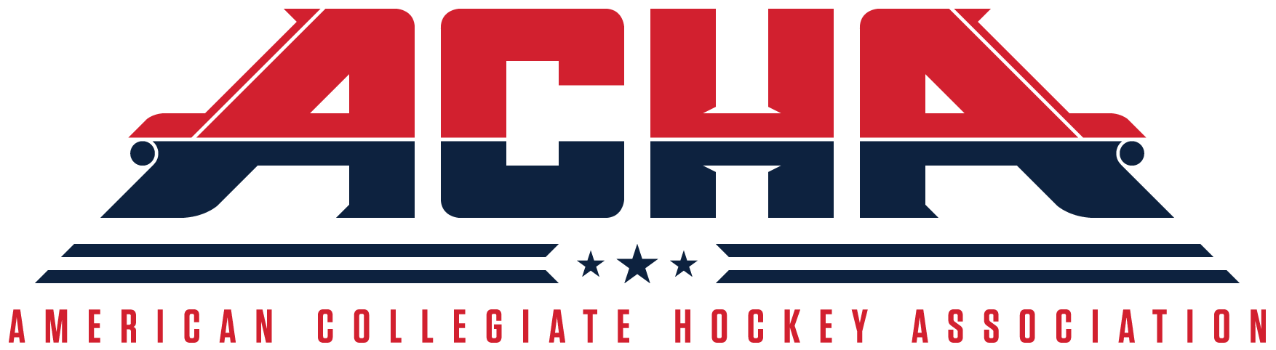
American Collegiate Hockey Association
Standardized Appeal Form
(Rev 05/22/18)

TYPE OF APPEAL: ELIGIBILITY ⃣ DISCIPLINE ⃣

Team Name and Division:__________________________________________________________

Name and Title of Person Filing Appeal:_______________________________________________

Name of Player Affected:___________________________________________________________

What ruling or decision is being appealed? (please include or attach a copy of the ruling or decision being appealed):

_______________________________________________________________________________

_______________________________________________________________________________

_______________________________________________________________________________

What is the basis of the Appeal? (please use more room if needed):

_______________________________________________________________________________

_______________________________________________________________________________

_______________________________________________________________________________

_______________________________________________________________________________

_______________________________________________________________________________

_______________________________________________________________________________

_______________________________________________________________________________

_______________________________________________________________________________

_______________________________________________________________________________

_______________________________________________________________________________

_______________________________________________________________________________

INSTRUCTIONS AND PROCEDURE

- Appeal Forms can be downloaded from the ACHA website or requested from the ACHA Director of Hockey Operations.

b. The completed Appeal Form and proof of appeal fee payment must be submitted to ACHA Director of Hockey Operations.

c. ACHA policies and rules themselves are not appealable. Only decisions and rulings based on ACHA policies and rules are appealable.

d. Appeals Process for Eligibility.

1. Ruling on a Player’s eligibility is a function of the Divisional Commissioner.

2. The Divisional Commissioner’s ruling may be appealed by a team within 15 days to an Appeals Committee consisting of the ACHA Executive Director, ACHA President, and respective ACHA Divisional Vice President. The appeal must be 1) in writing; 2) from a team; and 3) accompanied by a receipt showing payment to the ACHA of an appeal fee in the amount of $250.00 USD (payments can be made at shopacha.com). If the appeal is successful, $200.00 USD will be refunded to the appealing team. All appeal fees collected by the ACHA will be designated for distribution to charity.

3. The Appeals Committee shall render a decision within 15 days of receipt of appeal. The decision of the Appeals Committee is final.

e. Appeals Process for Discipline.

1. Ruling on a Player’s discipline is a function of the Divisional Commissioner.

2. Ruling on a Player’s supplemental discipline is a function of the Director of Hockey Operations.

3. The Divisional Commissioner’s ruling on discipline or the Director of Hockey Operations ruling on supplemental discipline may be appealed by a team within 15 days to an Appeals Committee consisting of the ACHA Executive Director, ACHA President, and respective ACHA Divisional Vice President. The appeal must be 1) in writing; 2) from a team; and 3) accompanied by a receipt showing payment to the ACHA of a non-refundable appeal fee in the amount of $250.00 USD (payments can be made at shopacha.com). If the appeal is successful, $200.00 USD will be refunded to the appealing team. All appeal fees collected by the ACHA will be designated for distribution to charity.

4. The Appeals Committee shall render a decision within 15 days of receipt of appeal. The decision of the Appeals Committee is final.

