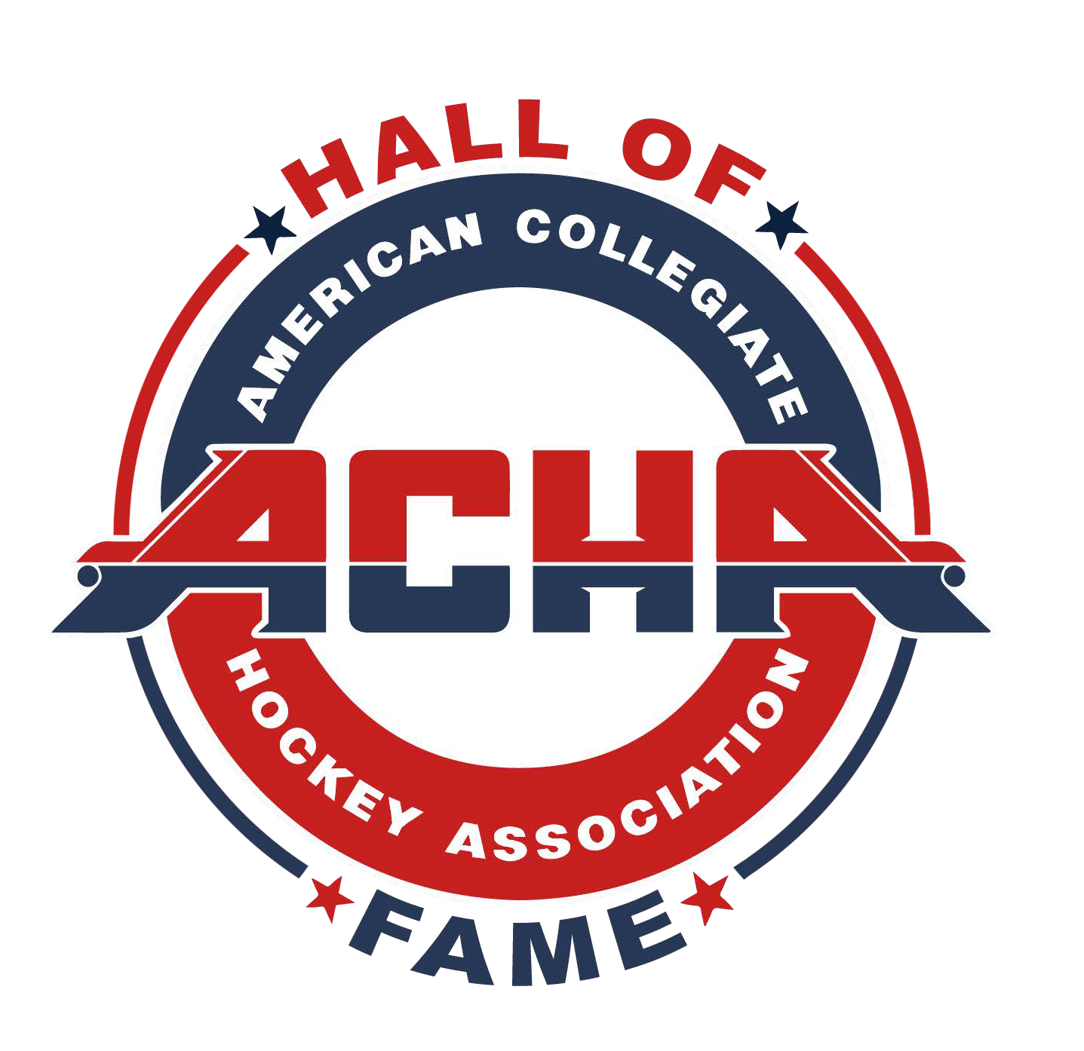
AMERICAN COLLEGIATE HOCKEY ASSOCIATION HALL OF FAME

NOMINATION CRITERIA

CATEGORIES
  - Player
  - Builder - this includes coaches, GM, referee or linesman, manager, trainer, advisor, officer of a league of the ACHA, officer of the ACHA, and other.

REQUIREMENTS FOR ELECTION
An individual must have contributed in a meaningful and positive way to the growth, betterment, and success of the ACHA. The individual must have a minimum of two years of service or play and be removed from service or play for a minimum of two years. The only exception is for that of builder and/or player with ten or more years of active service to the ACHA who is still active. This individual can be elected during his/her active service by the same method as is outlined for election.

BOARD OF ELECTION
The election board for both the nomination list and the Hall of Fame (HOF) will be made up of 11 members: The active members of the ACHA Board of Directors (7) and the commissioners (4).

NOMINATION
Any active member of a program of the ACHA can nominate an individual for consideration for election to the HOF. To be accepted the candidate must receive 6 of 11 votes. Once accepted as a nominee, the individual will remain on the eligibility list for a period of ten years. After that time the nominee will be removed from the list but may be re-nominated. Membership to the HOF requires 8 of 11 votes.

DATES OF NOMINATION AND ELECTIONS
Candidate’s nomination form must be submitted by January 15. The dates for election are January
31st for the nomination class and February 15th for the Hall of Fame class.

SIZE OF NOMINATION CLASS AND SIZE OF HALL OF FAME CLASS.
At any one time there can be any number of nominees on the list for membership into the Hall of Fame. Each year a minimum of one player and one builder must be elected to the HOF. Each year a maximum of 7 players and 5 builders may be elected to the HOF.

REMOVAL FROM THE ACHA HALL OF FAME
A member of the HOF may be removed as a member for conduct unbecoming their election to the hall. Removal is subject to the same vote for membership.

American Collegiate Hockey Association Hall of Fame Nomination

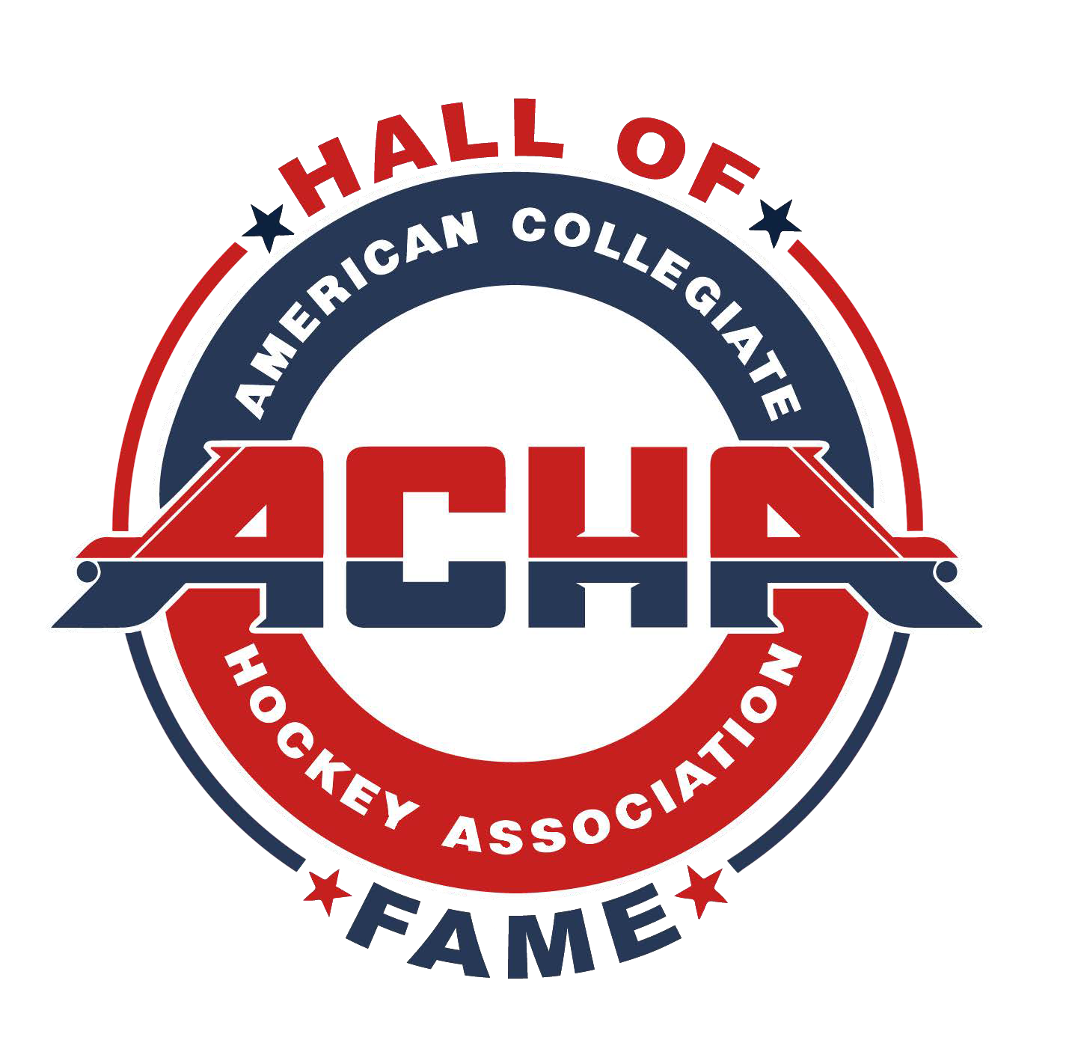
AMERICAN COLLEGIATE HOCKEY ASSOCIATION HALL OF FAME

NOMINATION FORM

NOMINATION FOR (PLEASE CHECK ONE):

PLAYER

BUILDER

NOMINEE’S NAME: CURRENT ADDRESS: CITY: STATE: ZIP: PHONE #1: PHONE #2: EMAIL ADDRESS(ES): TEAM(S):
POSITION(S) HELD:

SUBMITTER’S NAME: ADDRESS: CITY: STATE: ZIP: PHONE #1: PHONE #2: EMAIL ADDRESS(ES): TEAM:
POSITION:

SUPPORTING DOCUMENTATION

Please provide a written narrative about the person being nominated and include compelling facts and reasons about why the nominee should be included in the ACHA Hall of Fame. Letters of recommendation from peers (maximum 3) are also appropriate.

APPLICATION DEADLINE

All nominations must be received by the ACHA by January 15. Submit electronically to cbarnett@achahockey.org.

American Collegiate Hockey Association Hall of Fame Nomination

