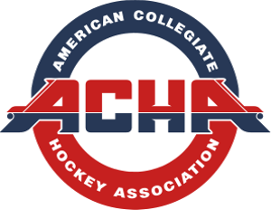

Requirements to play NON-ACHA teams
In order to play Non-ACHA teams the following steps need to occur:
- ACHA teams are required to obtain a sealed USAH roster (T1 Roster) from the opponent which they can get from USAH after they register and are claimed.

- This roster must be sent to both the ACHA team and to the Director of Hockey Operations, at least 2 weeks before the scheduled game.

- The roster provided will be used as proof of insurance coverage to USAH in case of injury.

- If the roster is not received, no one involved in the game will be covered by USAH insurance and the ACHA advises not to play without the insurance coverage.

- There is a link on the ACHA website with a sample of a USAH sealed roster.

- If you are playing an NCAA team, you should contact the Director of Hockey Operations who will provide you with instructions to obtain a special event sanction form for each NCAA game which must be submitted to USA Hockey to maintain insurance.

